A Pictorial History of Thai Diplomacy in the Rattanakosin Era
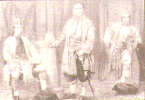 | - Siamese Special Envoys sent to England in 1857
Contact with foreigners began during the reign of King Rama III when special envoys from Western countries began to arrive in Bangkok. During the Reign of King Mongkut (Rama IV) Treaties of Friendship were concluded, consular representatives were established while Special Envoys were despatched to England and France.
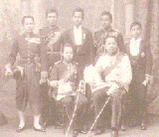 | - H.R.H.Crown Prince Mahavajiravudh, members of the Royal Family and staff of the Siamese Legation in London.
During the Reign of King Chulalongkorn (Rama V) Siamese diplomatic missions were established with the first Legation in London in 1882. They provided a more convenient way of contacting foreign governments. Foreign consuls in Bangkok were transformed into legations as a response to this initiative.
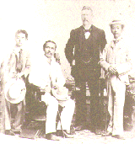 | - King Chulalongkorn, members of the Royal Family and Phra Phites Panich (John Anderson), Siamese Consul General, during a visit to Singapore in 1896.
King Chulalongkorn was the first monarch to travel abroad beginning with trips to neighbouring countries and culminating with two visits to Europe.
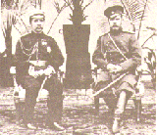 | - King Chulalongkorn with Tsar Nicholas II at Tsarkeo Selo during the State Visit to Russia in 1897.
The reign of King Chulalongkorn coincided with the expansion of western colonialism. During his visit to Europe in 1897 he took the opportunity to cultivate personal contact with his counterparts. Such initiative was part of his personal effort towards the maintenance of independence, sovereignty and territorial integrity of his country.
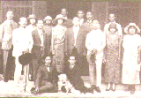 | - King Vajiravudh with his suite during his State Visit to the Straits Settlement and the Federated Malay States in 1924.
During the reign of King Vajiravudh (Rama VI) Thailand joined the Allies in the First World War, participated in the Peace Conference at Versailles and became a member of the League of Nations. Unequal treaties were successfully revised and the ex-territorial system terminated.
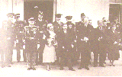 | - King Prajadhipok and his suite in front of the White House during his state Visit in April 1931.
King Prajadhipok (Rama VII) visited countries both within and outside the region. He was the first monarch to pay State Visits to the United States and Japan.
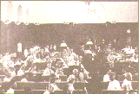 | - International Conference on Opium Smoking held in Bangkok in November 1931.
During the reign of King Prajadhipok, Thailand hosted a number of international conferences. The League of Nations sponsored International Conference on Opium Smoking in 1931, with was presided over by H.H. Prince Tridos, Minister of Foreign Affairs.
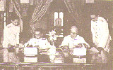 | - The signing of the Non-Aggression Pact between Thailand and Great Britain at the Government House in June 1940.
During the reign of King Ananda Mahidol (Rama VIII) the Second World War erupted. Thailand pursued an independent foreign policy and successfully maintained its independence, sovereignty and territorial integrity throughout that period.
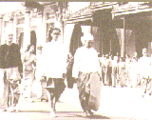 | - His Majesty the King during the State Visit to the Union of Burma in 1960.
To strengthen external relations His Majesty the King paid State Visits to neighbouring countries and subsequently to the United States and Western Europe.
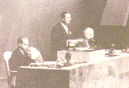 | - H.R.H. Prince Wan Waithayakorn, Minister of Foreign Affairs, served as President of the United Nations General Assembly in 1956.
At the termination of the Second World War Thailand became a member of the United Nations and other related international organisations. In the 11th session of the United Nations General Assembly, H.R.H. Prince Wan Waithayakorn, Minister of Foreign Affairs, was elected President.
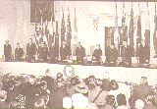 | - Southeast Asia Treaty Organisation Council Meeting in London 1971.
During the Cold War, Thailand cooperated with countries in the free world to contain the threat from communism through a collective security system both at multilateral and bilateral levels. In 1954 Thailand became a member of the Southeast Asia Treaty Organisation.
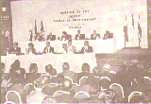 | - The Fourth Meeting of Heads of Government of the Association of Southeast Asian Nations in 1992.
Thailand has always been aware of the importance and potential of Southeast Asia. In 1967 Thailand together with four other regional countries founded the Association of Southeast Asian Nations (ASEAN). This regional organisation is now highly recognised by the international community

